**Control Structures**

**Scenario 1:**

BEGIN

FOR customer IN (

SELECT loan.LoanID, customer.DOB

FROM Loans l

JOIN Customers customer ON loan.CustomerID = customer.CustomerID

) LOOP

IF MONTHS_BETWEEN(SYSDATE, customer.DOB) / 12 > 60 THEN

UPDATE Loans

SET InterestRate = InterestRate - 1

WHERE LoanID = customer.LoanID;

END IF;

END LOOP;

COMMIT;

END;

/SELECT * FROM Loans;

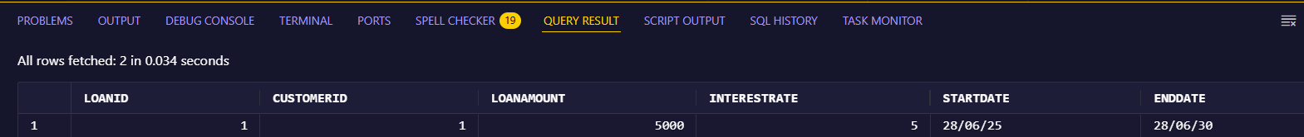**Output:**

**Scenario 2:**

ALTER TABLE Customers ADD IsVIP VARCHAR2(10);

BEGIN

FOR customer IN (SELECT * FROM Customers) LOOP

IF customer.Balance > 10000 THEN

UPDATE Customers

SET IsVIP = 'TRUE'

WHERE CustomerID = customer.CustomerID;

END IF;

END LOOP;

COMMIT;

END;

/

SELECT Name, Balance, IsVIP FROM Customers;

**Output:**

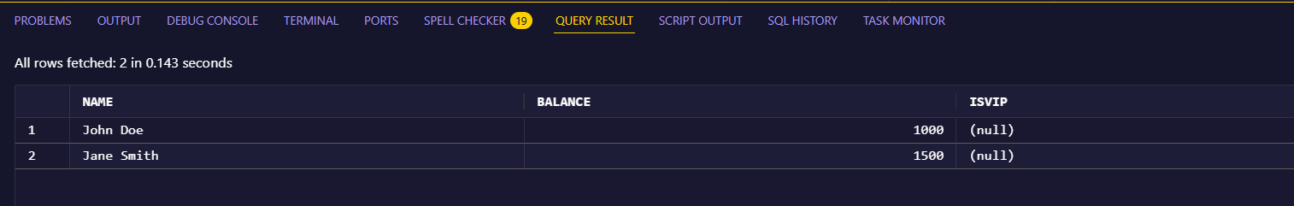

**Scenario 3:**

INSERT INTO Loans VALUES (4, 1, 5000, 8, SYSDATE, SYSDATE + 5);

COMMIT;

BEGIN

FOR customer IN (

SELECT * FROM Loans

WHERE EndDate <= SYSDATE + 30

) LOOP

DBMS_OUTPUT.PUT_LINE('Reminder: Loan ID ' || customer.LoanID || ' is due soon.');

END LOOP;

END;

/

**Output:**

